Visual Query Interface (Diagrammatic Query View / DAG view)

The primary goal of this functionality is to allow user construct an IQuery object by adding constraints on the selected classes/categories and linking them using graphical user interface. Thus it allows user to construct query for getting data set of interest.

References
- Search Meta data design document to know details of how to search and select classes / categories of interest.
- Add / Edit Limit design document to know details of how to add constraints on selected classes / categories
- Query Engine design documents for design details of IQuery interface.

The DAG view should support following functionalities:

- View the class / category constraints added to the query in the form of graph nodes.
- Link the selected class / category constraints visually
- Edit / delete query constraints
- Resolve ambiguities if multiple paths are available between the source and target class / category constraints to link.
- The textual representation of the query expression

The diagram below shows the basic workflow of the DAG view:
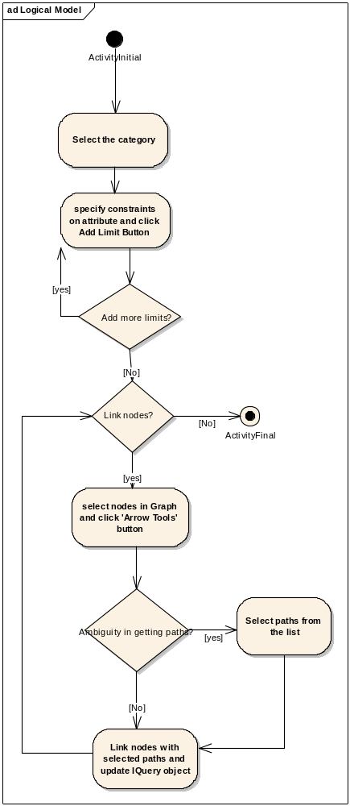

Design
The main requirement of DAG view is to visually represent class / category constraints as a node of the graph and allow linking of constraints as edges of the graph. NetBean’s Graph Library supports visualization and editing of node-edge structures using drag'n'drop style of work (org-netbeans-graph.jar) and it is platform independent. Hence we have decided to use this library to build visual representation of the IQuery object.

The design section of this document has been divided into 3 sections:

- User Interface: This section describes the design of the user interface of the DAG view. It describes the classes that constitute visualization of the DAG view. The class diagram below details the classes and interactions amongst them.

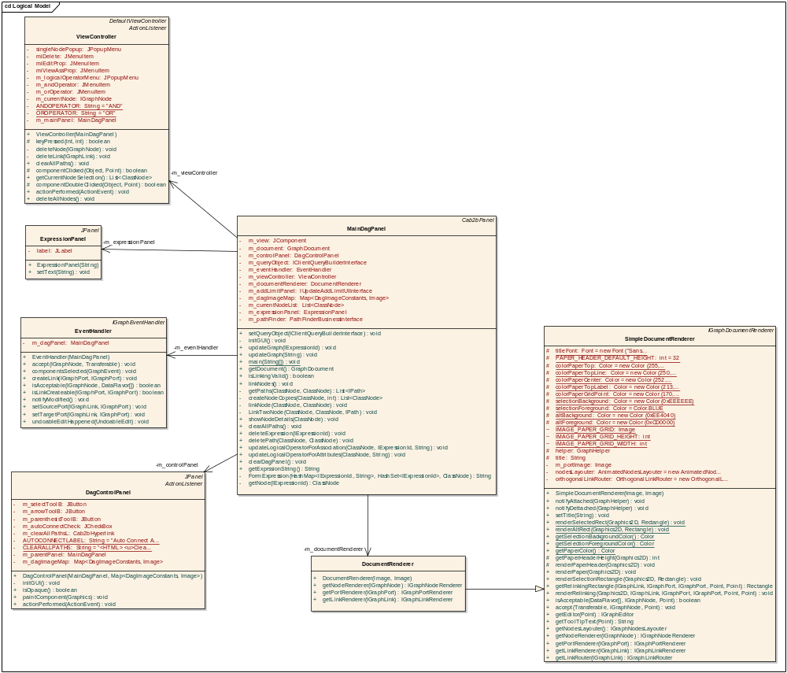

The details of UI classes are as below:

MainDagPanel: The MainDagPanel class is the core class of the DAG view which is responsible for handling different user actions related to constructing visual query.
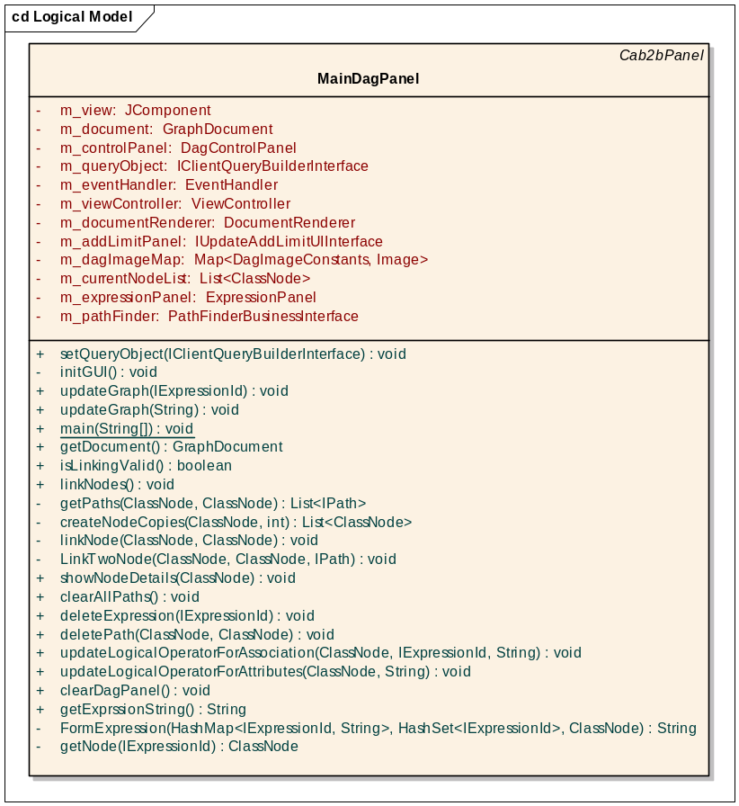
This class handles following functionalities
- In order to render nodes, links on the panel, MainDagPanel has to create JComponent that will render the nodes and links using GraphFactory.createView(…) method from NetBean’s graph library. This method requires IGraphDocument, IGraphDocumentRenderer, IGraphViewController, IGraphEventHandler class instances. Following classes implements above mentioned interfaced and the MainDagPanel class creates instances of these classes in initGUI() method and creates view for rendering graph.
  - GraphDocument implements IGraphDocument
  - EventHandler implements IGraphEventHandler
  - ViewController implements IGraphViewController
  - DocumentRenderer implements IGraphDocumentRenderer
- This class also holds reference of IClientQueryBuilder class which is a wrapper over IQuery object. The Backend query building section describes it in details.
- UpdateGraph(…) method adds IExpression object representing the constrained category to the graph . Whenever a user fires add limit event, this method is called to add new IExpression object to the graph
- LinkNode(…) method of this class links two nodes if valid caB2B server has path between selected entities. The caB2B server curates the paths between all the categories of the entire domain Models loaded into the caB2B sever. These paths could be inter-model or intra-model. Refer to Domain Model path curation design document for more details. If the system contains multiple paths between selected expressions, the ambiguity resolver allows user to select paths of interest and links nodes with selected paths.
- deletePath(), deleteExpression() methods deletes selected link and expression from the UI as well as backend query object
- GetExpressionString (): Method returns the textual representation of IQuery object.
- Specify the AND / OR operator between linked nodes.

DagControlPanel : This class controls different user activities such as liking selected nodes, clearing DAG view.

ExpressionPanel: This class provides the textual representation query object to user.

Apart from these UI class, there are classes which hold UI details of every link, node that is rendered on the DAG panel. These classes and their details are as below:

- Graph node related classes: The class diagram below shows classes involved in implementing graph node functionality. These are the classes which hold information such as how to render the node, what expression does node holds, what are the other nodes that are linked to this expression.

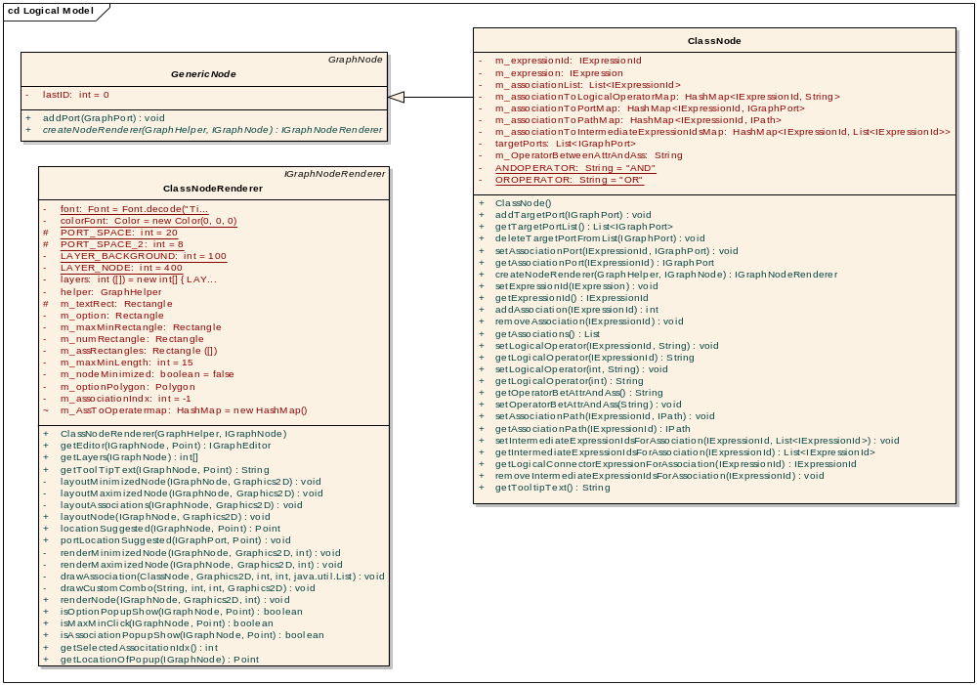
- Graph Link related classes: The below classes implement graph link related functionality. The classes mainly do the rendering of graph link.
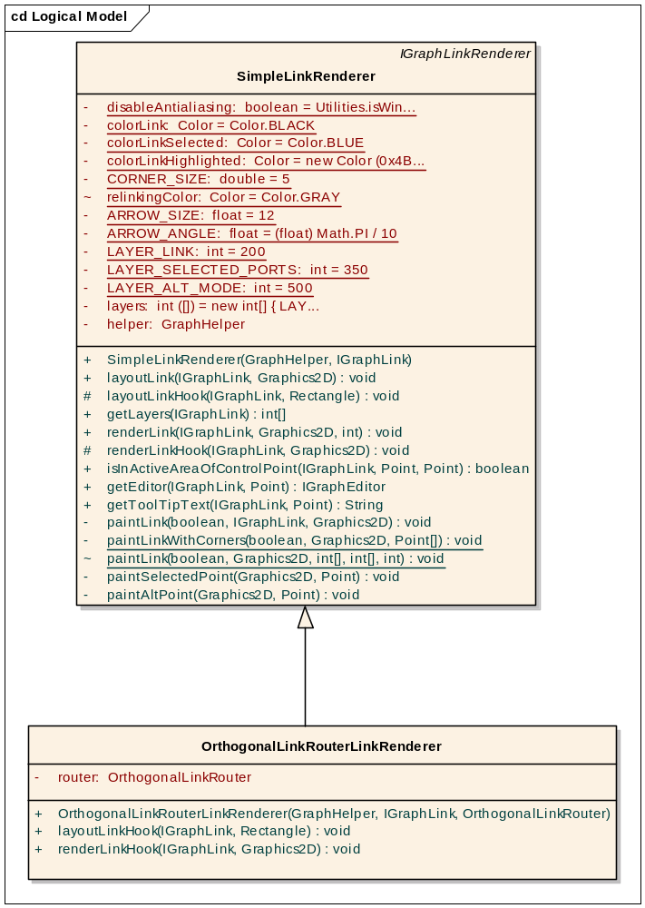
In order to link two nodes, one need to add ports to source and destination nodes. Below are the classes which render ports on the nodes
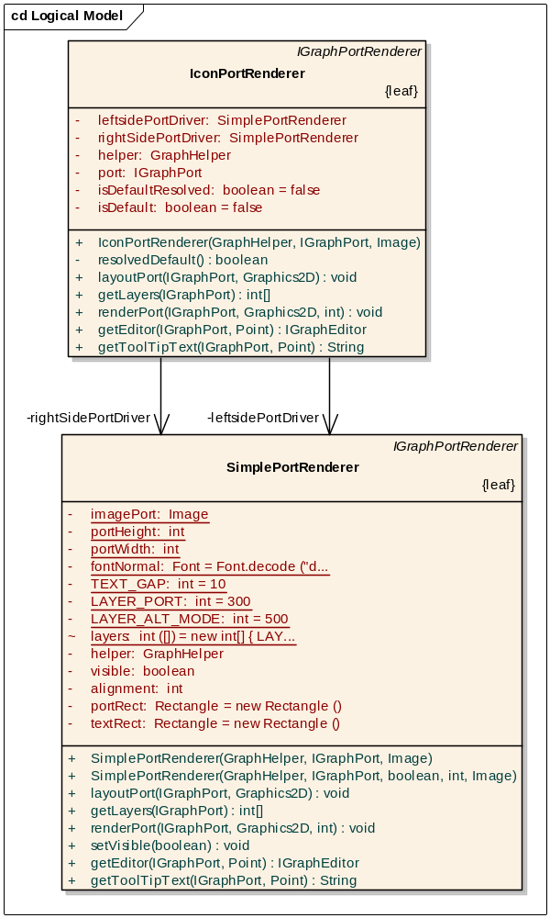

- Backend query building : The IQuery object needs to be modified when ever user links nodes, adds/ deletes links, nodes from the MainDagPanel. The IClientQueryBuilder interface provides different method signatures to update IQuery object according user interaction. The ClientQueryBuilder is the concrete class which implements IClientQueryBuilder interface.
The class diagram below shows different methods in this class

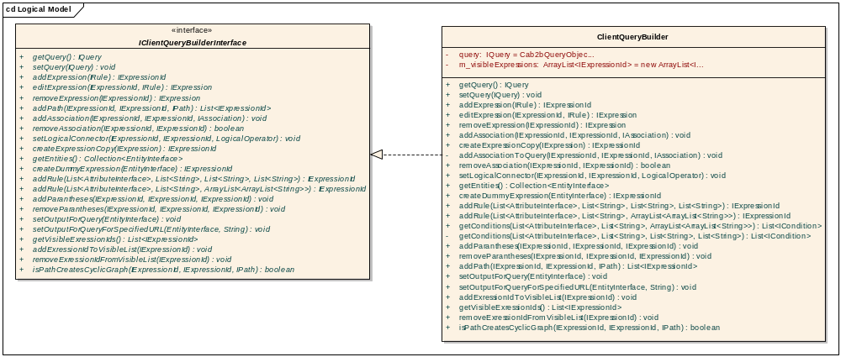

The important methods of this class are
  - addExpression(…) : This method adds the constrained category element to a IQuery when user perform AddLimit functionality. This method takes the IRule object as input.
  - addPath(…): Method adds the associations between source and destination expression specified by IPath.
  - removeExpression(..): Removes expression with specified ExpressionId from graph
  - removeAssociation(..): Removes specified association between the two ExpressionIds

- Ambiguity resolver: The functionality provides class to visually show all the possible paths between selected source and target expression entities and allow user select paths of interest. This functionality queries caB2B server to get all the available paths between source and destination expression entity

The class diagram below shows classes involved in implementing this functionality.
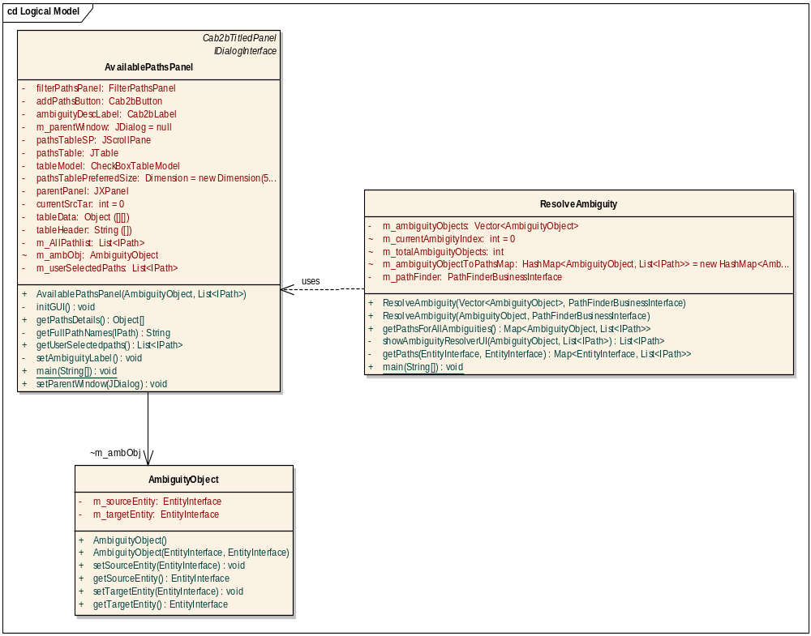

ResolveAmbiguity : This class queries caB2B server to get all the possible paths between source and destination entities and pops dialogbox containing instance of AvailablePathsPanel in order to allow user select multiple paths if there are. In case of single path, this class doesn’t show dialog.

AvailablePathsPanel: This panel holds UI to show ambiguous paths.

AmbiguityObject: The bean class holding the details of the entities between which system has to resolve find paths and resolve ambiguity

